Exercise 1: Inventory Management System
Scenario:
You are developing an inventory management system for a warehouse. Efficient data storage and retrieval are crucial.
Code:
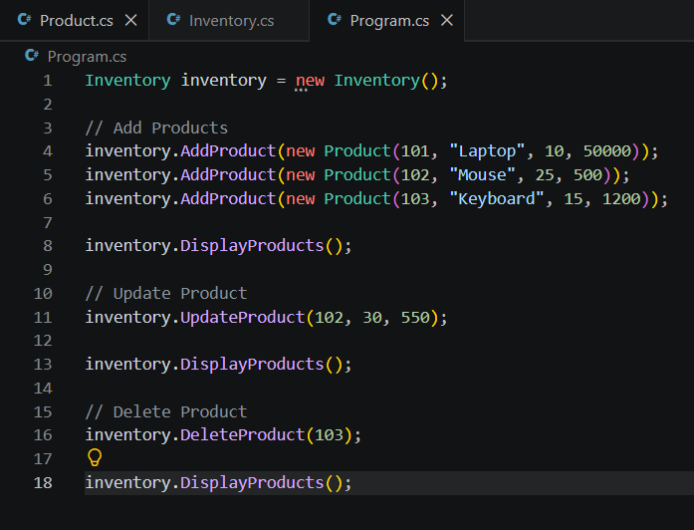
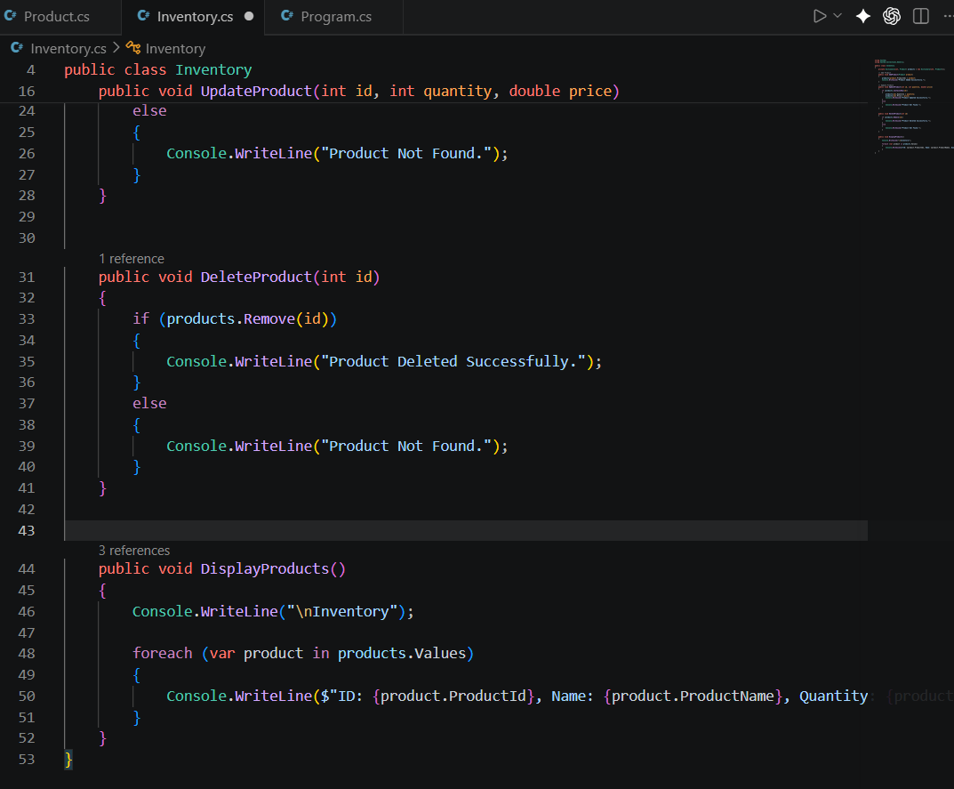

Output:
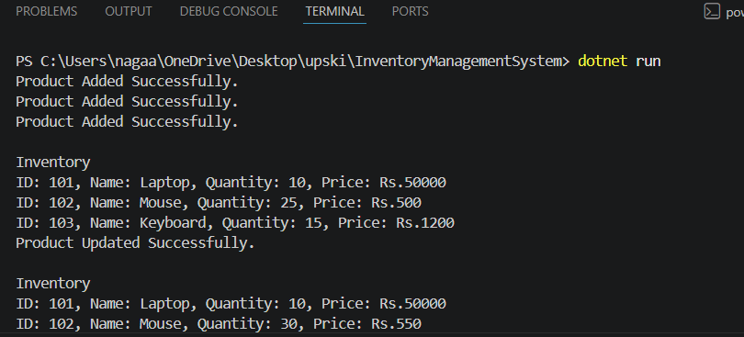
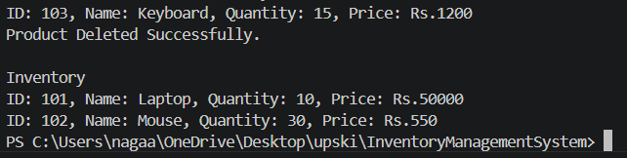
Exercise 2: E-commerce Platform Search Function
Scenario:
You are working on the search functionality of an e-commerce platform. The search needs to be optimized for fast performance.
Code:
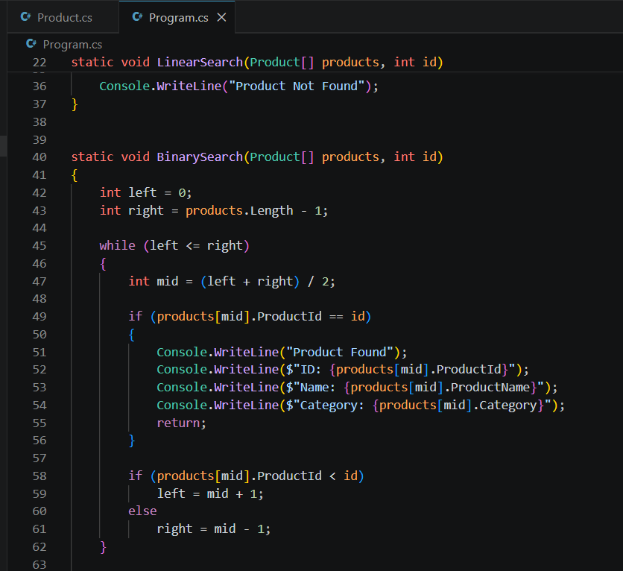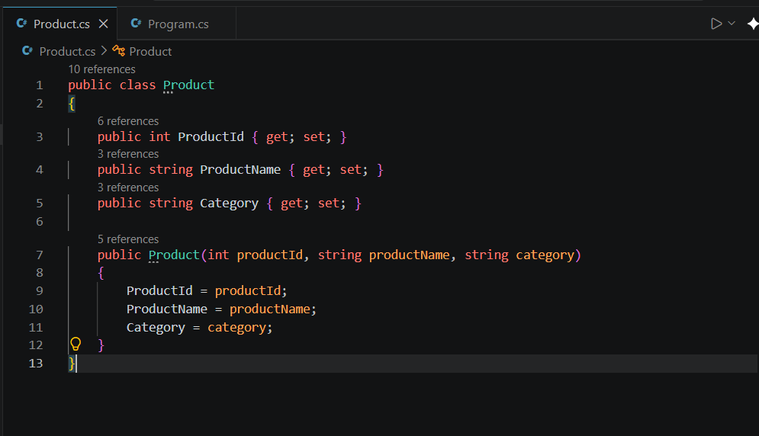

Output:
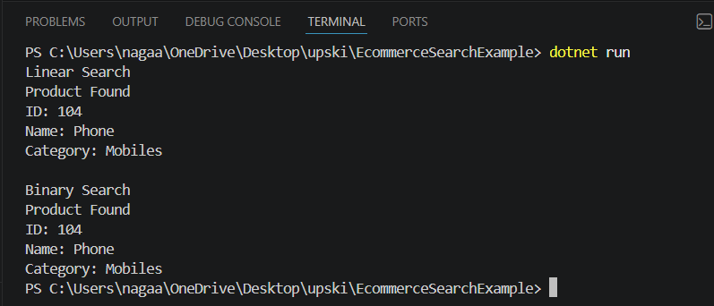
Exercise 3: Sorting Customer Orders
Scenario:
You are tasked with sorting customer orders by their total price on an e-commerce platform. This helps in prioritizing high-value orders.
Code:
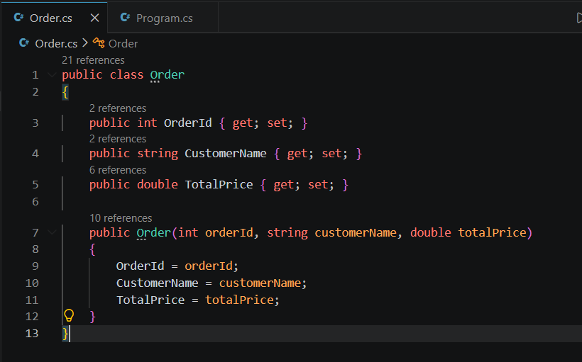
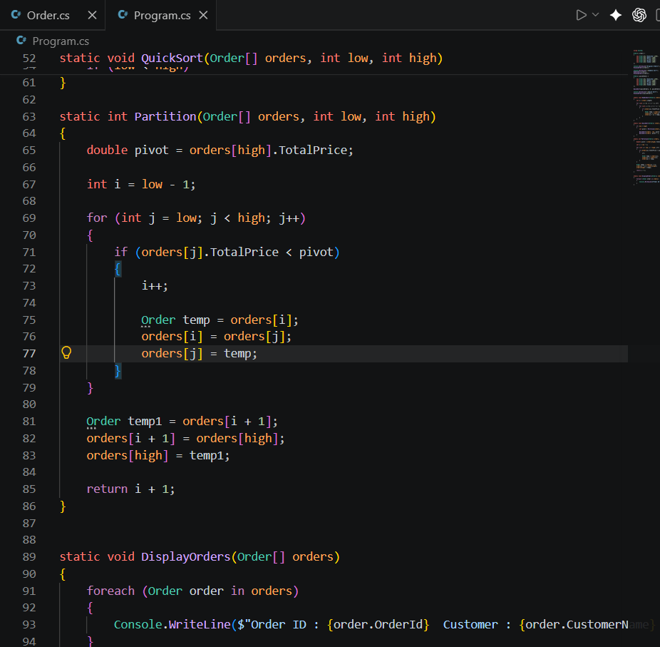
Output:
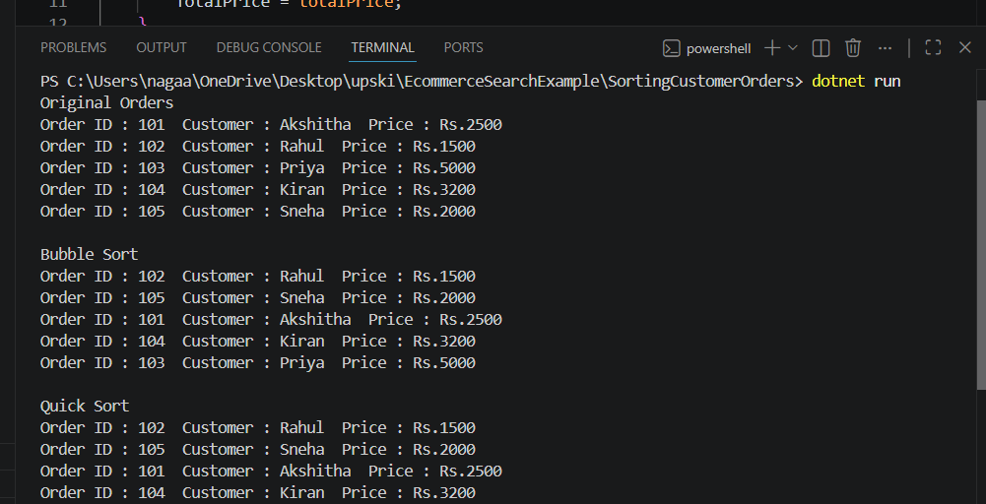
Exercise 4: Employee Management System
Scenario:
You are developing an employee management system for a company. Efficiently managing employee records is crucial.
Code:
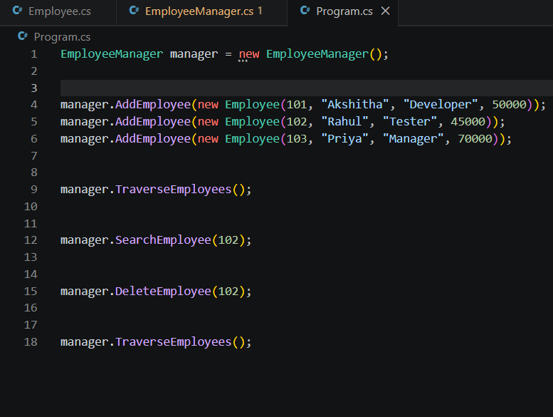
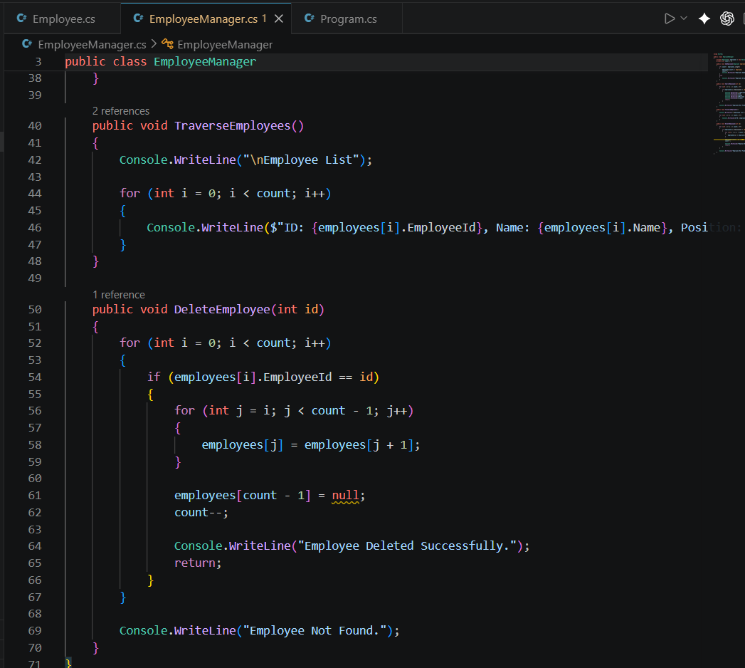
Output:
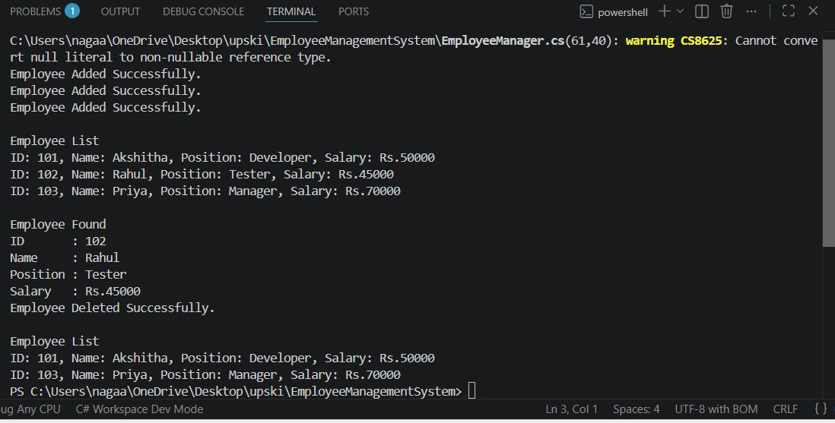

Exercise 5: Task Management System
Scenario:
You are developing a task management system where tasks need to be added, deleted, and traversed efficiently.
Code:
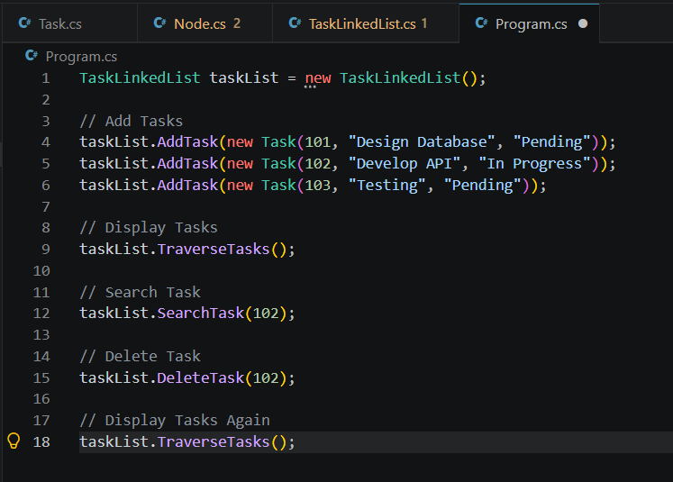
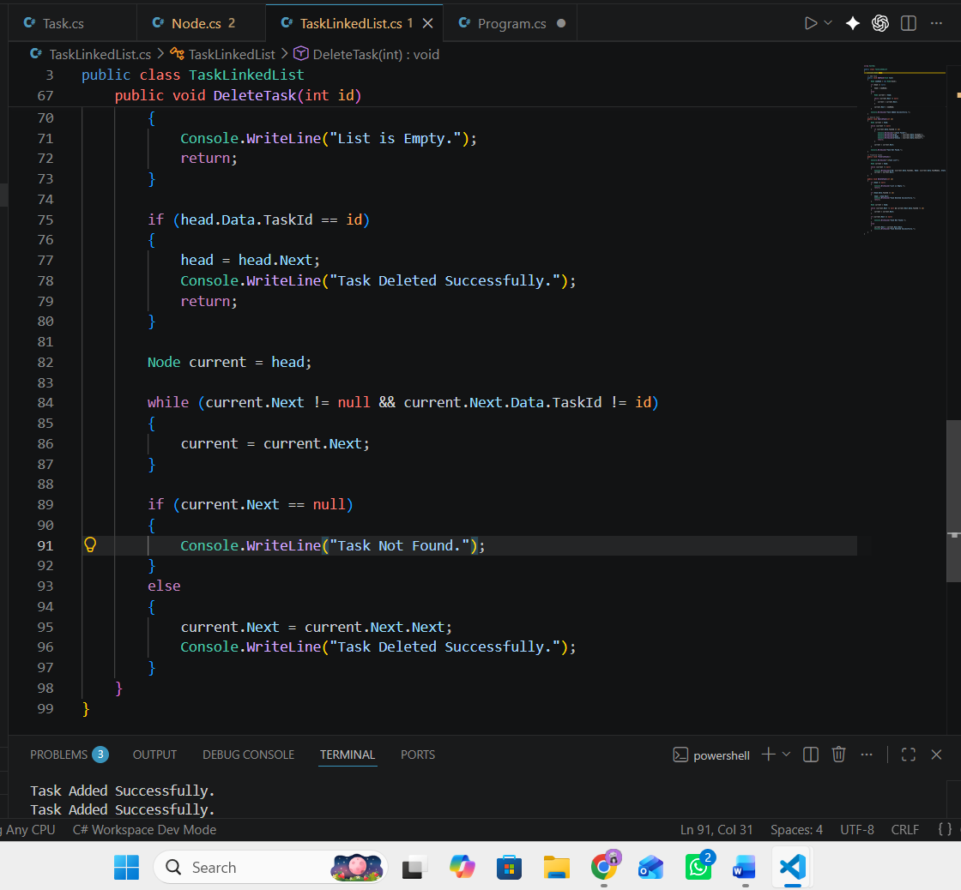
Output:
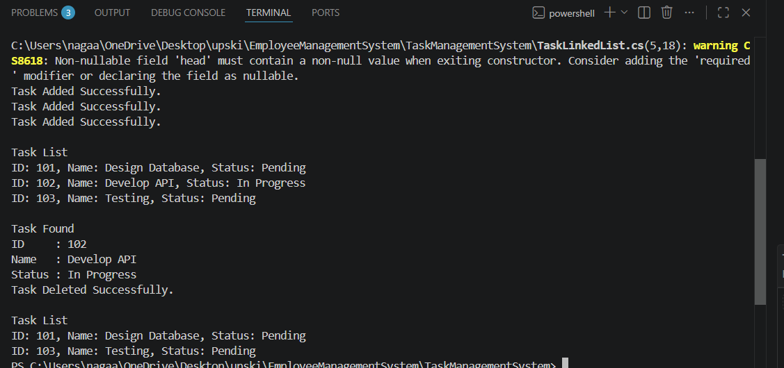

Exercise 6: Library Management System
Scenario:
You are developing a library management system where users can search for books by title or author.
Code:
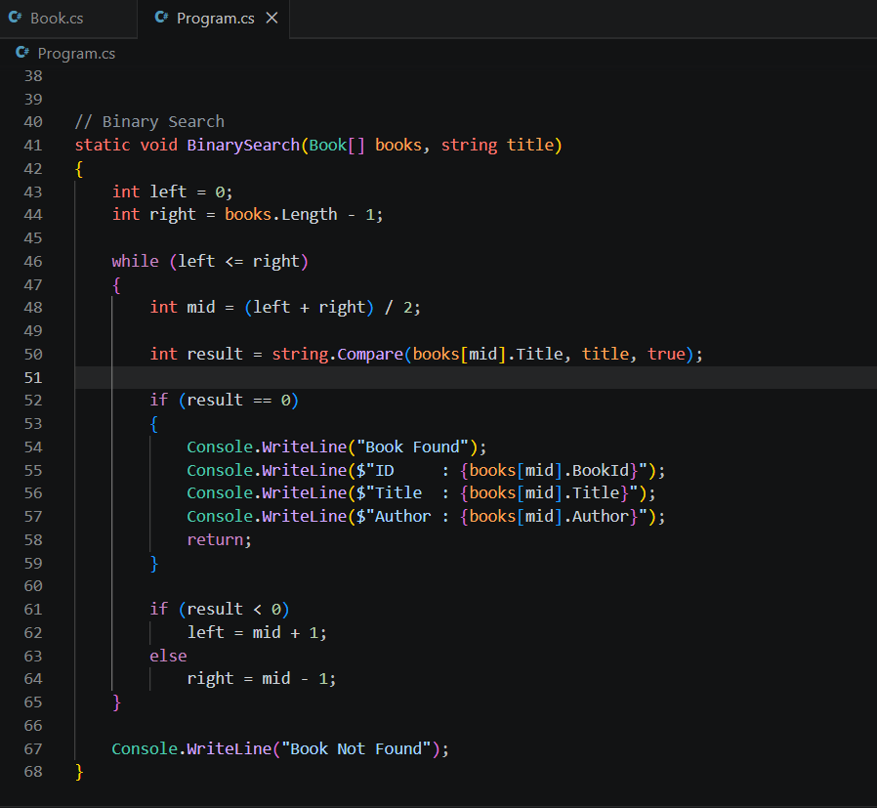
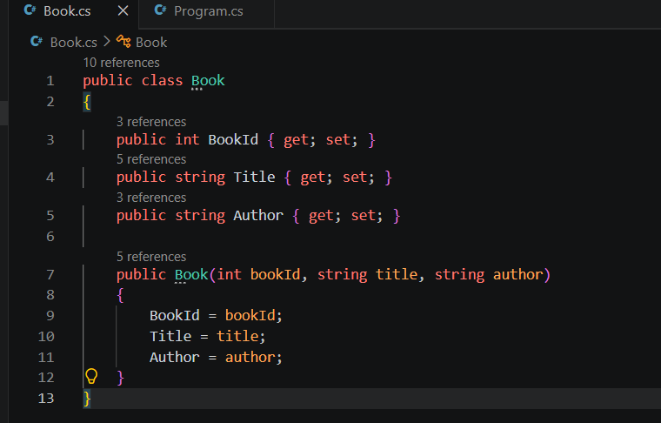
Output:
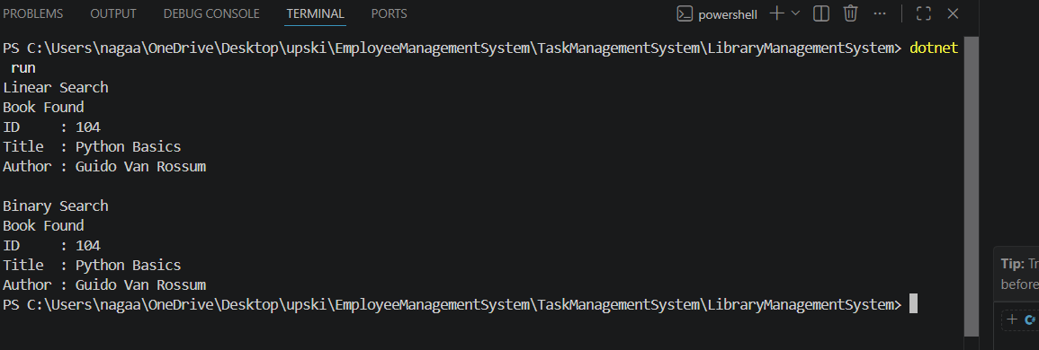
Exercise 7: Financial Forecasting
Scenario:
You are developing a financial forecasting tool that predicts future values based on past data.
Code:
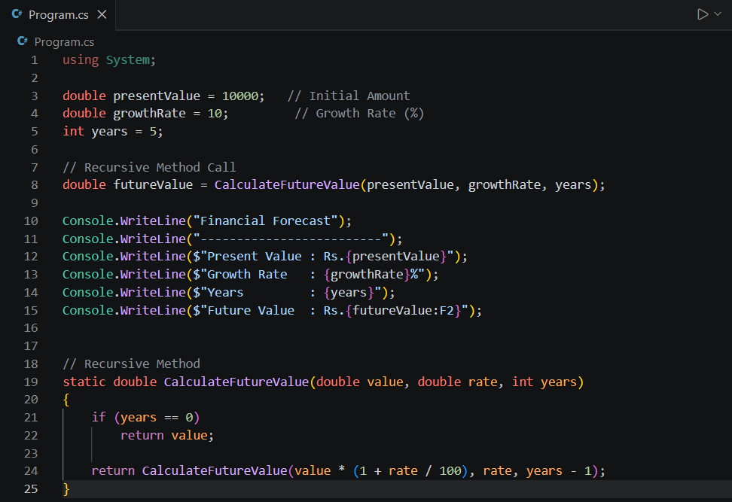
Output:
